Github assignments

1. Create a directory ‘project_dir’ and cd to ‘project_dir’

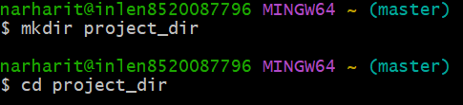

2.Intilialize git version database

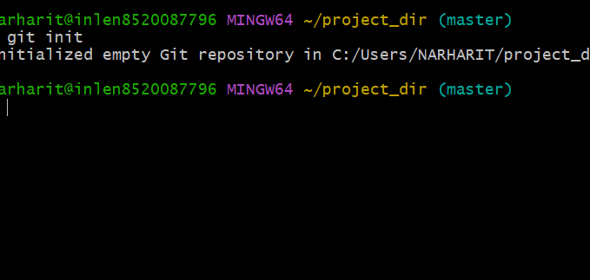

3.Create a new file inex.html

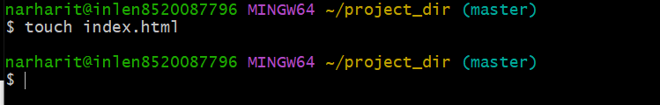

4.Check the git status.you should find index.html as untracked file

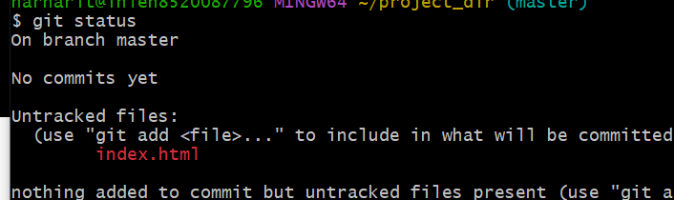

5.stage the index.html file

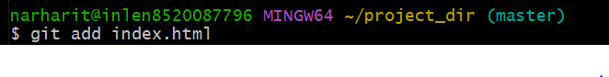

6.Commit index.html

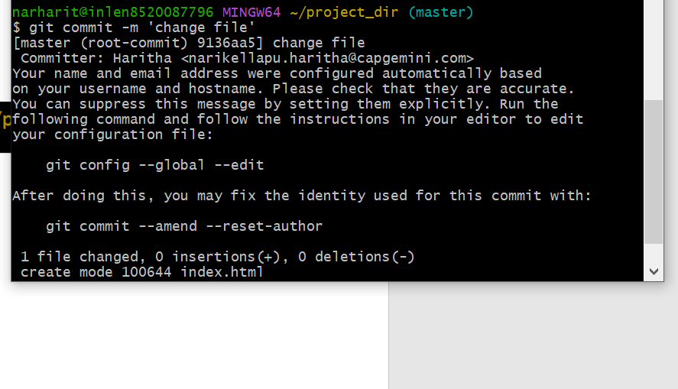7.Make few changes in index.html and create a new file info.txt file

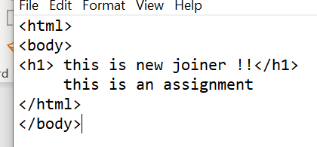



8.Check git status.You should find index.html and info.txt as untracked

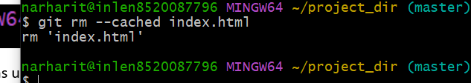

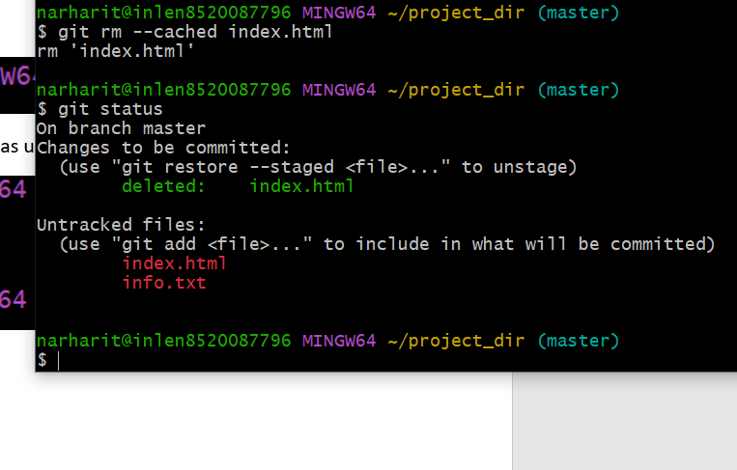

9.configure git to ignore all txt files

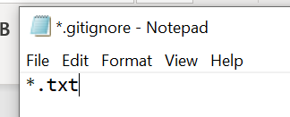

10.Again check the git status.You should find only .html as untracked file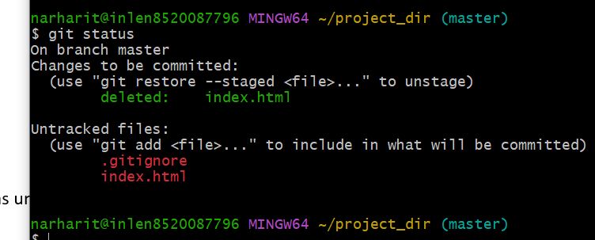

11.State and commit index.html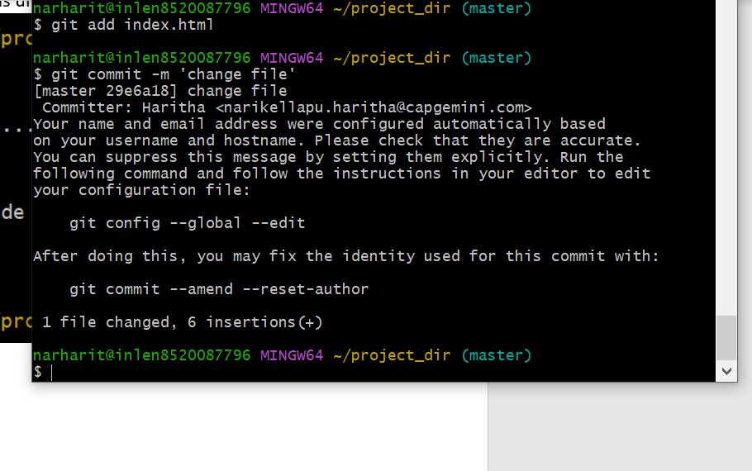

12.log all your comments so far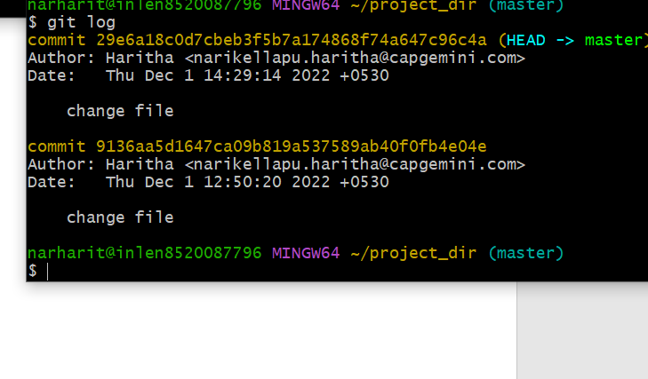

13.Make some changes in index.html

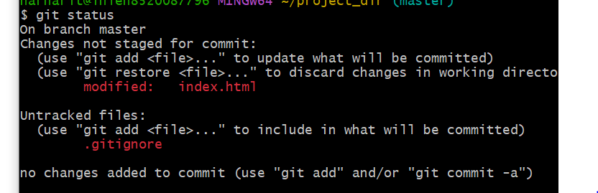

14.Revert the change made in the

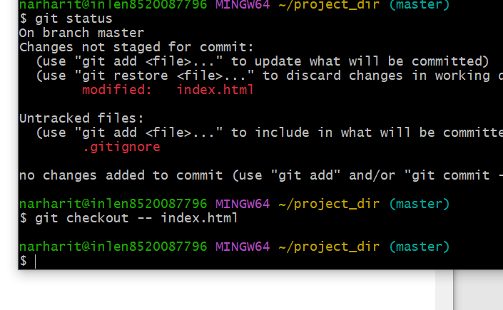15.Again change index.html

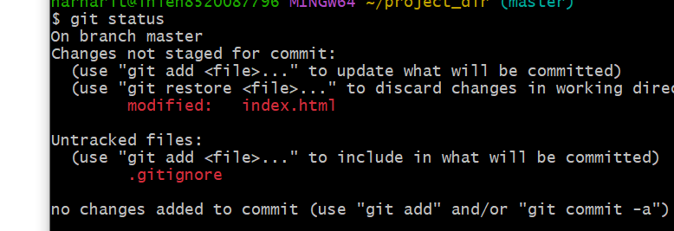

16.Stage index.html

17.Revert back last stage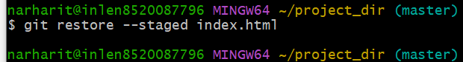

18.Rename add command to my add 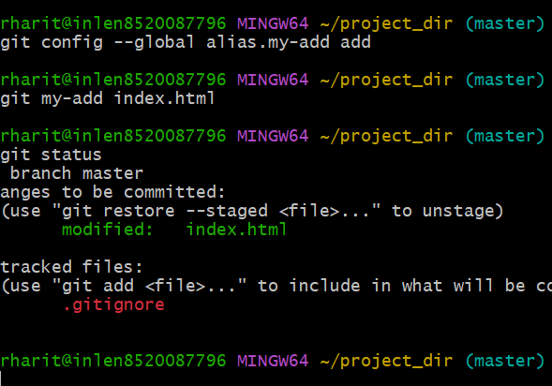

19..Using my_add command stage index.html.html again&commit the changes 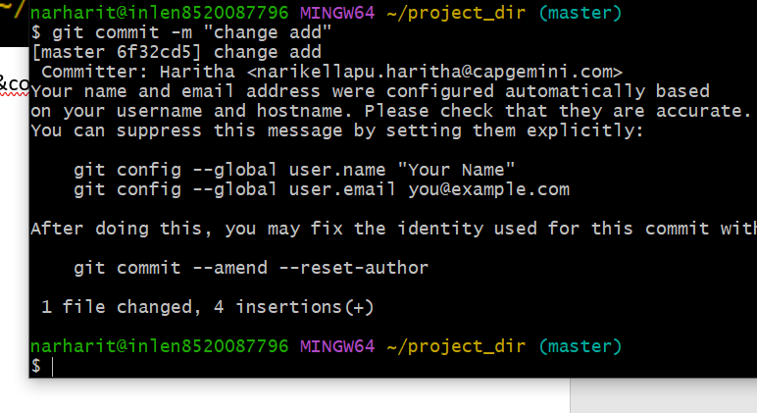

20.Revert the last commit

